**Setting up TextEdit**

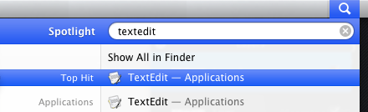

**1) Launch TextEdit –** To launch **TextEdit**, click on the magnifying glass on the upper right corner of the screen and type **TextEdit.** Click on **TextEdit** with your mouse or hit enter.

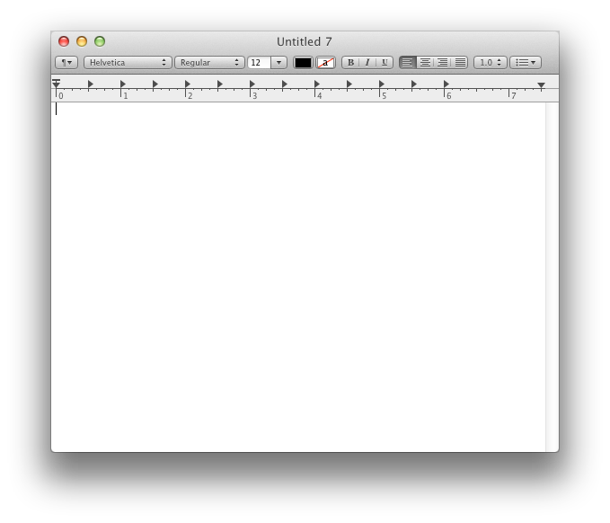

**2) You should see something like this.**

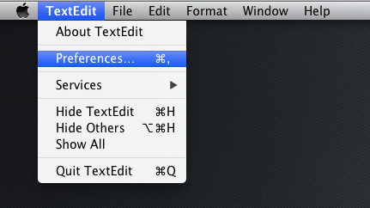

**3)** Click **TextEdit >> Preferences** from the toolbar

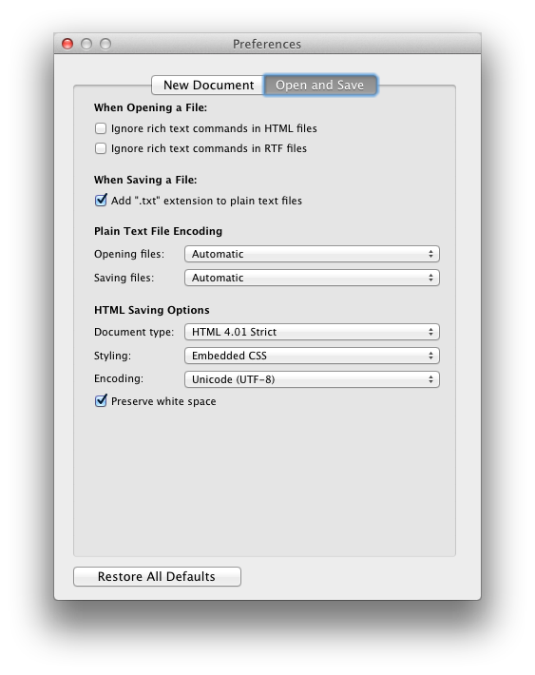

**4)** A dialog like the one below should pop up. If the **Open and Save** tab is not already selected, click on that tab.

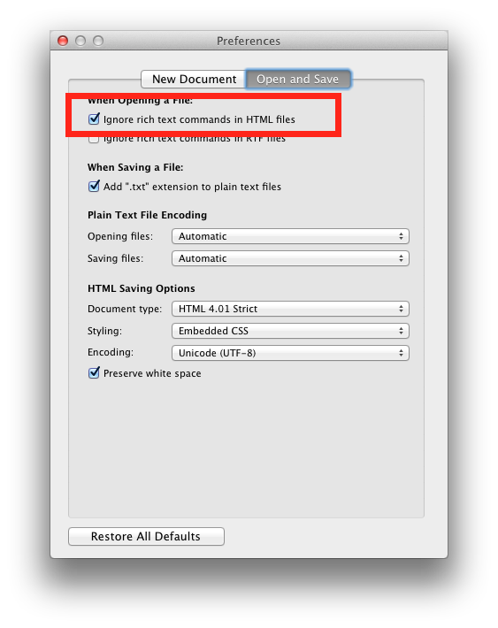

**5) Make sure the box next to Ignore rich text commands in HTML files is checked.**

**6) Now close this dialog, by hitting the red circle button at the upper left corner of the dialog. You’re all set and ready to start creating your website.**